1. **Listening**  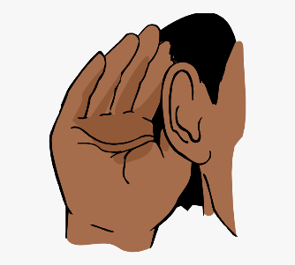

Listening isn’t just about staying quiet—it means really absorbing what someone else is saying. Listening also is a critical component of healthy communication. After all, much of the learning in school depends on a child’s ability to listen to what the teacher is saying.

**How to Practice**

When reading a book to your children, periodically stop and ask them to tell you about what you’re reading. Pause and say, “Tell me what you remember about the story so far.” Help them fill in any gaps they're missing and encourage them to keep listening as you continue. Additionally, don’t allow them to interrupt others when they’re talking.

1. **Following Directions** 

Kids who struggle to follow directions are likely to experience a variety of consequences.

Before you can expect your child to get good at following directions, however, it’s essential that you become well-versed in [giving directions](https://www.verywellfamily.com/kids-dont-listen-change-how-you-give-directions-1094955).

For example, don’t give a young child more than one direction at a time. Instead of saying, “Pick up your shoes, put your books away, and wash your hands,” wait until the shoes are picked up before giving the next command.

Another [mistake to avoid](https://www.verywellfamily.com/mistakes-parents-make-when-giving-kids-directions-1094795) is phrasing your directions as a question. Asking, “Would you please pick up your toys now?” implies that your kids have the option to say no. Once you’ve given your children directions, ask them to repeat back what you said. Ask, “What are you supposed to do now?” and wait for them to explain what they heard you say.

**How to Practice**

Praise your child for following directions by saying things like, “Thank you for turning off the TV the first time I told you to.” If your children struggle to follow directions, give them opportunities to practice following simple commands. Say things like, “Please pass that book to me,” and then provide immediate praise for following directions.